Software Design Document
(SDD)

Project Name | HEALTH AI Co-Creation & Innovation Platform
Course | Seng 384 Software Project IV
Group No / Name | MedTech Connect
Group Members | Senanur ÇİNKİL 202228011  İpek GÜRSOY 202228023  Emre TEK 202228046
Submission Date | 23.04.2026
Version | 1.0
Revision History
Date | Version | Change Description | Author
21.04.2026 | 1.0 | Initial version | Senanur ÇİNKİL

Table of Contents
Table of Contents 2
1. Introduction 3
1.1 Purpose 3
1.2 Scope 3
1.3 Reference Documents 3
1.4 Definitions and Abbreviations 3
2. Architectural Design 3
2.1 Architectural Overview 3
2.2 Layers 3
2.3 Deployment Diagram 3
3. Component Design 3
3.1 Component List 3
3.2 Component Interaction Diagram 4
4. Database Design 4
4.1 ER Diagram 4
4.2 Table Definitions 4
4.2.1 users 4
4.2.2 posts 4
4.2.3 meeting_requests 5
4.2.4 activity_logs 5
5. API Design 5
5.1 Authentication (Auth) 5
5.2 Post Management (Posts) 5
5.3 Meeting Requests (Meetings) 6
5.4 Admin 6
6. UI Design 6
6.1 Screen List and Navigation 6
6.2 Wireframes / Mockups 6
7. Security Design 6
8. State Diagrams 7
8.1 Post Lifecycle 7
8.2 Meeting Request Lifecycle 7
9. SRS–SDD Traceability Matrix 7
10. Appendices (Optional) 7

(Right-click and select “Update Field” in Word to refresh)

1. Introduction

1.1 Purpose

This Software Design Document (SDD) describes the system design of the HealthAI Co-Creation & Innovation Platform.
It explains how the functional and non-functional requirements defined in the Software Requirements Specification (SRS) are realized at both the architectural and component levels.

1.2 Scope
This design encompasses all system components, including:
- User registration and authentication system
- Post creation and management
- Post discovery and filtering
- Meeting request process
- Administrative panel
- Logging system
Note: The system:
- does not store patient data,
- does not support file uploads, and
- conducts meetings outside the platform.
.

1.3 Reference Documents

SRS v2.0 – 21 Nisan 2026

SENG 384 Proje Brief

1.4 Definitions and Abbreviations

API: Application Programming Interface

JWT: JSON Web Token

RBAC: Role-Based Access Control

REST: HTTP tabanlı servis mimarisi

ORM: Object Relational Mapping

2. Architectural Design

2.1 Architectural Overview
The system adopts a Layered Architecture in combination with a Client–Server Architecture.
Structure:
- Frontend (React / React Native)
- Backend (Spring Boot)
- Database (PostgreSQL)
- External Services (Email, Zoom)
This layered structure is also illustrated in the architectural diagram provided in the SRS..

2.2 Layers
.
Layer | Responsibility | Technology Choice
Presentation | User interface and user interaction | React / React Native
Business Logic | Business rules and validation processes | Spring Boot
Data Access | Database operations (CRUD) | Hibernate / JPA
Database | Data storage | PostgreSQL

2.3 Deployment Diagram

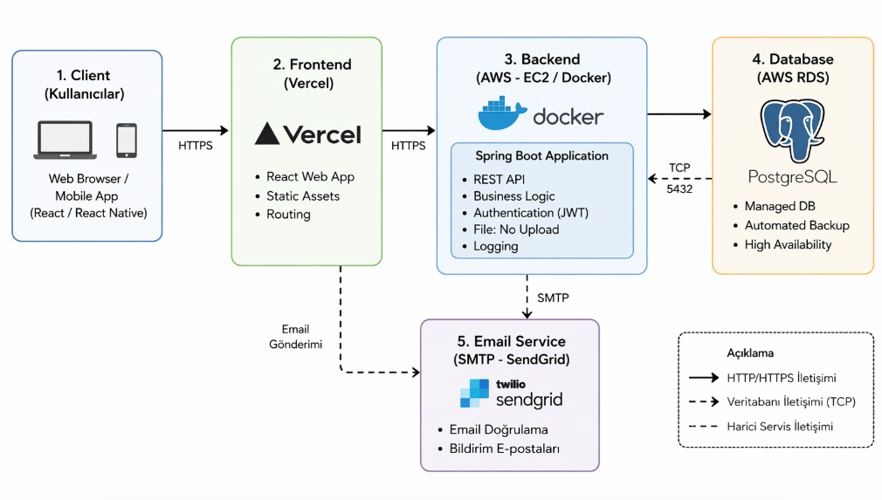3. Component Design

3.1 Component List
Component | Responsibility | Technology / Notes
AuthModule | User registration, authentication, email verification, and session management | Spring Boot + Spring Security + JWT + Java Mail (SMTP)
PostModule | Post creation, updating, deletion, and lifecycle management | Spring Boot REST API + JPA (Hibernate)
MatchingModule | Post searching, filtering, and location-based matching | Spring Boot + JPA Query + Pagination & Filtering
MeetingModule | Creation of meeting requests, time scheduling, and NDA validation | Spring Boot REST + JSON handling
AdminModule | User and post management, as well as system statistics | Spring Boot Admin APIs + Role-based access control (RBAC)
AuditModule | Activity logging, log querying, and CSV export | Spring Boot + Logging (SLF4J/Logback) + CSV export
NotificationModule | Email notifications and in-app notification mechanisms | Spring Boot + Logging (SLF4J/Logback) + CSV exportx

3.2 Component Interaction Diagram

Component Interaction Flow

Kullanıcı → AuthModule

AuthModule → JWT üretir ve kullanıcıya döner

Kullanıcı → PostModule

PostModule → Database’e kayıt yapar

Kullanıcı → MatchingModule

MatchingModule → filtrelenmiş postları getirir

Kullanıcı → MeetingModule

MeetingModule → request oluşturur

Tüm işlemler → AuditModule tarafından loglanır

Bildirim gerekiyorsa → NotificationModule devreye girer

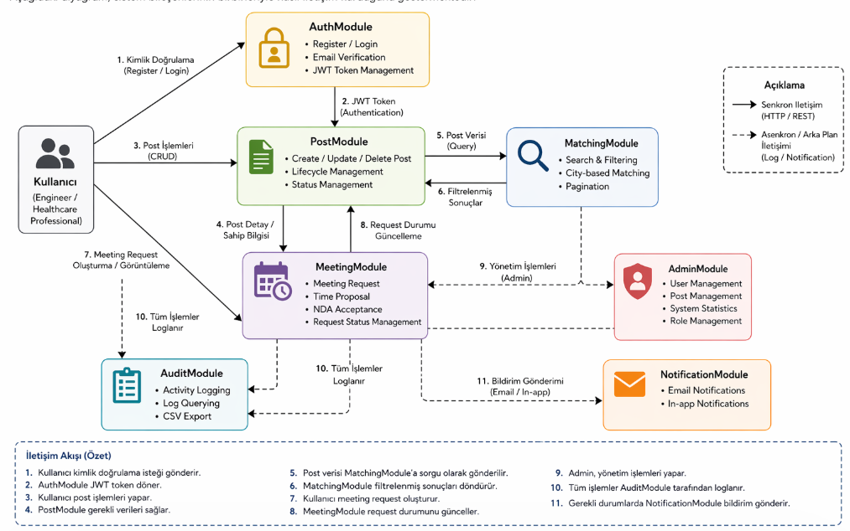4. Database Design

4.1 ER Diagram

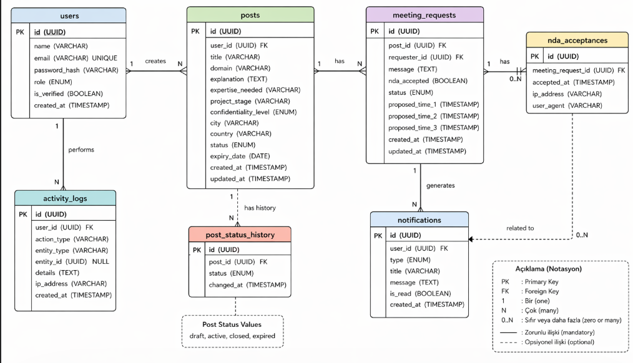4.2 Table Definitions

4.2.1 users

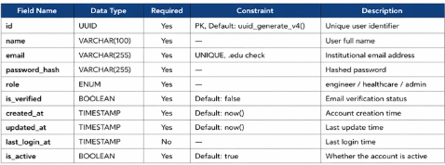

4.2.2 posts

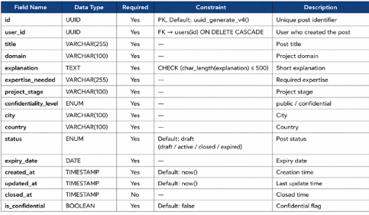

4.2.3 meeting_requests
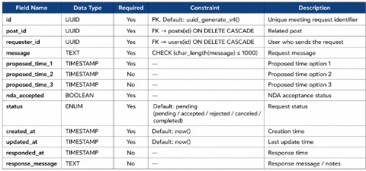

4.2.4 activity_logs

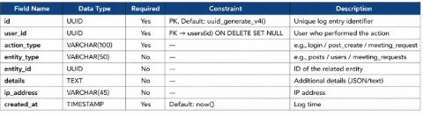

4.2.5 notifications

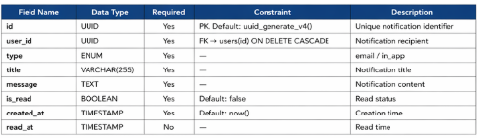

4.2.6 nda_acceptances

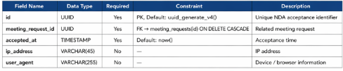

5. API Design

5.1 Authentication (Auth)
Method | Endpoint | Description | Auth | SRS Ref.
POST | /api/auth/register | Register a new user with institutional email | Public | FR-01
POST | /api/auth/login | Authenticate user and return JWT token | Public | FR-02
POST | /api/auth/verify-email | Verify user email address via token | Public | FR-02
POST | /api/auth/logout | Invalidate user session / logout | Authenticated | —

5.2 Post Management (Posts)
Method | Endpoint | Description | Auth | SRS Ref.
GET | /api/posts | Retrieve all posts with filtering options | Authenticated | FR-20
POST | /api/posts | Create a new post | Authenticated | FR-10
GET | /api/posts/:id | Retrieve detailed information of a post | Authenticated | Fr-24
PUT | /api/posts/:id | Update a post | Owner | FR-11
PATCH | /api/posts/:id/status | Change post status | Owner | FR-12
DELETE | /api/posts/{id} | Delete a post | Owner | Delete a post

5.3 Meeting Requests (Meetings)
Method | Endpoint | Description | Auth | SRS Ref.
POST | /api/meetings | Submit a meeting request for a post | Authenticated | FR-30
GET | /api/posts/{id}/meeting-requests | Get all meeting requests for a post (owner) | Owner | FR-32
PATCH | /api/meeting-requests/{id}/status | Update meeting request status (pending/scheduled/rejected) | Owner | FR-33
GET | /api/meeting-requests/{id} | Retrieve meeting request details | Authenticated | ------

5.4 Admin
Method | Endpoint | Description | Auth | SRS Ref.
GET | /api/admin/users | List all users | Admin | FR-42
PATCH | /api/admin/users/{id}/suspend | Suspend a user account | Admin | FR-43
GET | /api/admin/posts | Retrieve all posts with filters | Admin | FR-40
DELETE | /api/admin/posts/{id} | Remove inappropriate post | Admin | FR-41
GET | /api/admin/logs | Retrieve system activity logs | Admin | FR-52
GET | /api/admin/stats | Retrieve system statistics | Admin | FR-44

6. UI Design

6.1 Screen List and Navigation
The following table defines the main screens of the system and their navigation flow. Each screen corresponds to the functionalities defined in the SRS and supports the overall user journey.
Screen | Description | Access
Registration / Login | Allows users to register using a valid .edu email and log into the system. Includes email verification and authentication using JWT. | Public
Dashboard | Displays the main post feed with filtering and search functionality. Users can browse collaboration opportunities and navigate to other features. | Authenticated
Create Post | Provides a form for users to create a new collaboration post, including all required fields such as title, domain, expertise, and expiry date. | Authenticated
Post Detail | Displays detailed information about a selected post. Users can view full content and take actions such as expressing interest. | Authenticated
Meeting Request | Allows users to submit a meeting request with proposed time slots, message, and NDA acceptance. | Authenticated
Admin Panel | Provides administrative functionalities such as managing users, posts, and viewing system logs and statistics. | Admin
Profile | Enables users to view and update their profile information, manage account settings, and perform GDPR-related actions such as data export or deletion. | Authenticated
Post Feed (Filtered View) | Displays posts based on selected filters such as domain, project stage, and location. | Authenticated

6.2 Wireframes / Mockups

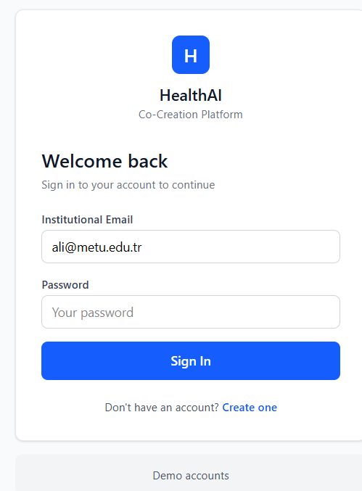

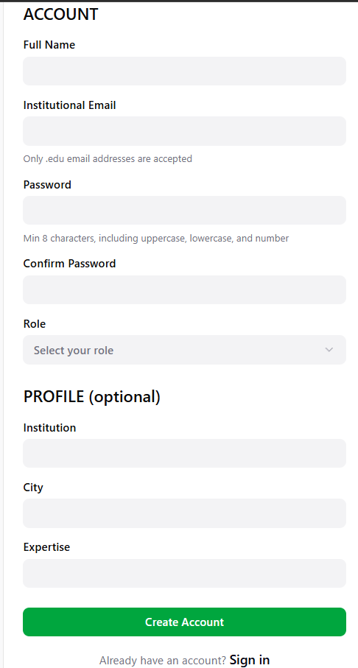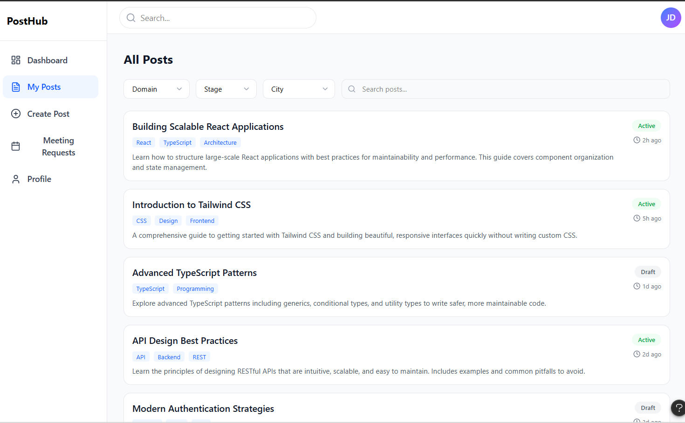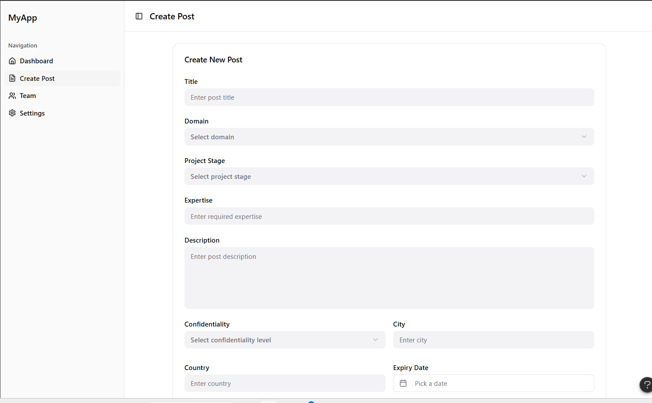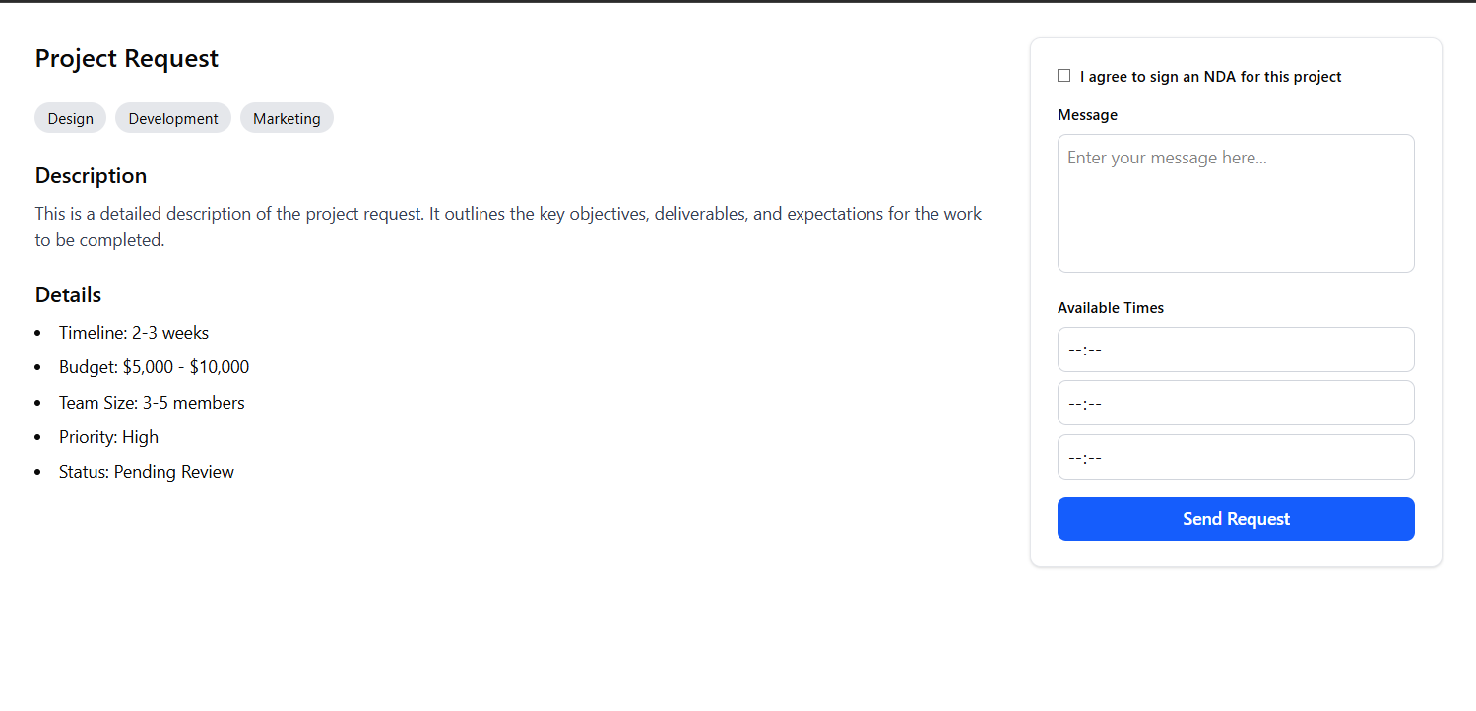

7. Security Design
Security Requirement | Design Decision | SRS Ref.
Authentication | The system uses JWT-based authentication. After successful login, a signed JWT token is issued and included in the Authorization header for all subsequent requests. This ensures stateless and secure session handling. | NFR-05
Password storage | User passwords are securely stored using bcrypt hashing algorithm with salting. Plain-text passwords are never stored in the system. | NFR-07
Authorization (RBAC) | The system implements Role-Based Access Control (RBAC) with three roles: Engineer, Healthcare Professional, and Admin. Access to endpoints is controlled using middleware/filters that validate user roles. | FR-04
Session management | Sessions are managed using JWT tokens with a 24-hour expiration time. Token renewal or re-login is required after expiration. Tokens are stored securely on the client side. | NFR-05
GDPR compliance | Users can delete their account and all associated data and export their data in JSON format. No sensitive medical data is stored, ensuring compliance with GDPR requirements. | NFR-08, NFR-09, NFR-10
Rate limiting | API endpoints are protected with rate limiting mechanisms to prevent abuse and brute-force attacks (e.g., login attempts). | NFR-01
Secure Communication | All communication between client and server is secured using HTTPS (TLS 1.2+) encryption. | NFR-04
Input Validation | All user inputs are validated both on client and server side to prevent SQL Injection, XSS, and malformed data attacks. | NFR-14
Logging & Monitoring | All critical actions (login, post creation, meeting request) are logged via the AuditModule, enabling traceability and security monitoring. | FR-50

8. State Diagrams

8.1 Post Lifecycle

Draft → Active | User clicks the “Publish” button after filling all required fields
Active → Meeting Scheduled | Post owner accepts a meeting request and schedules a meeting
Meeting Scheduled → Partner Found | Meeting is successfully completed and collaboration is confirmed
Active → Expired | The expiry date is reached, and the system automatically closes the post
Active → Closed | Post owner manually clicks “Close Post”
Draft → Deleted | User cancels or deletes the post before publishing
Active → Removed (Admin) | Admin removes the post due to policy violation

The post lifecycle starts in the Draft state when a user creates a post.
Once the user publishes the post, it transitions to Active.

From the Active state:

It can move to Meeting Scheduled when a meeting request is accepted

It can move to Closed manually by the user

It can move to Expired automatically when the expiry date is reached

Finally, a scheduled meeting may result in Partner Found, indicating successful collaboration.

8.2 Meeting Request Lifecycle

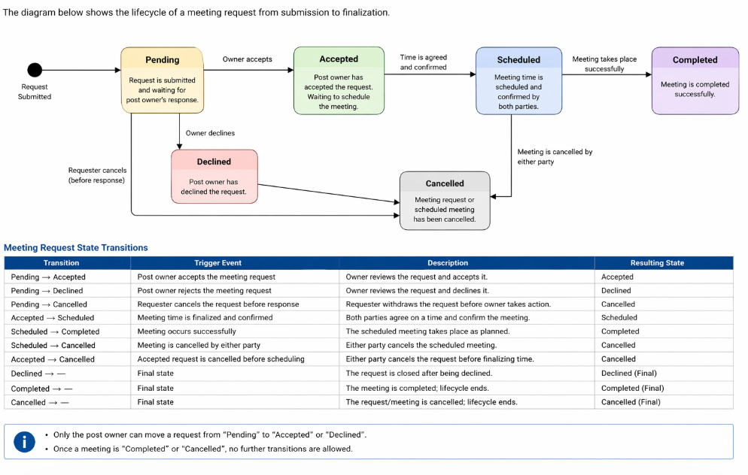9. SRS–SDD Traceability Matrix
SRS Ref. | Requirement Summary | SDD Component / API Addressed | SDD Section
FR-01 | .edu email restriction | AuthModule – Registration API (/api/auth/register) | Section 3.1, 5.1
FR-02 | Email verification | AuthModule – Verify Email API (/api/auth/verify-email) | Section 3.1, 5.1
FR-03 | Role selection during registration | AuthModule – Registration Logic | Section 3.1, 7
FR-04 | RBAC enforcement | AuthModule + AdminModule – Role-based middleware | Section 3.1, 7
FR-05 | Admin role restriction | AuthModule – Role assignment logic | Section 3.1
FR-06 | JWT session management | AuthModule – JWT Authentication | Section 3.1, 5.1, 7
FR-10 | Create post | PostModule – Create Post API (/api/posts) | Section 3.1, 5.2
FR-11 | Post lifecycle management | PostModule – Update Post API (/api/posts/{id}) | Section 3.1, 5.2, 8.1
FR-12 | Change post status | PostModule – Status API (/api/posts/{id}/status) | Section 3.1, 5.2, 8.1
FR-13 | Manual post close | PostModule – Close action | Section 3.1, 8.1
FR-14 | Post expiry | PostModule – Scheduled job / auto-close | Section 3.1, 8.1
FR-15 | Post required fields | PostModule – Validation logic | Section 3.1, 4.2
FR-16 | Confidential post flag | PostModule – Confidential field handling | Section 3.1, 4.2
FR-20 | Browse and filter posts | MatchingModule – List Posts API (/api/posts) | Section 3.1, 5.2
FR-21 | Filter by domain/stage/location | MatchingModule – Filtering logic | Section 3.1, 5.2
FR-22 | Keyword search | MatchingModule – Search logic | Section 3.1
FR-23 | Post card display | UI Layer – Dashboard screen | Section 6.1
FR-24 | Post detail page | PostModule – Get Post API (/api/posts/{id}) | Section 5.2, 6.1
FR-30 | Send meeting request | MeetingModule – Create Request API (/api/posts/{id}/meeting-requests) | Section 3.1, 5.3
FR-31 | Meeting request fields | MeetingModule – Validation logic | Section 3.1, 4.2
FR-32 | View meeting requests | MeetingModule – List Requests API | Section 3.1, 5.3
FR-33 | Update meeting status | MeetingModule – Status API (/api/meeting-requests/{id}/status) | Section 3.1, 5.3, 8.2
FR-34 | Display meeting link | MeetingModule – UI integration | Section 6.1
FR-35 | One request per post | MeetingModule – Business rule validation | Section 3.1
FR-40 | Admin post management | AdminModule – Admin Posts API | Section 3.1, 5.4
FR-41 | Remove post | AdminModule – Delete Post API | Section 3.1, 5.4
FR-42 | List users | AdminModule – Users API (/api/admin/users) | Section 3.1, 5.4
FR-43 | Suspend user | AdminModule – Suspend API | Section 3.1, 5.4
FR-44 | System statistics | AdminModule – Stats API | Section 3.1, 5.4
FR-50 | Activity logging | AuditModule – Logging system | Section 3.1, 5.5
FR-51 | Log details | AuditModule – Log structure | Section 4.2
FR-52 | Filter logs | AuditModule – Log Query API | Section 5.5
FR-53 | Export logs | AuditModule – CSV Export API | Section 5.5

